Prof. John Schellnhuber about the Papa Encyclical Laudato Si’ (18/06/2015)
Laudato si’, the Papal Encyclical [1], is compiled at a crucial moment in the history of humanity: today.
We are faced with the great challenge of limiting global warming to below 2°C while fostering development for the poorest. But we are also experiencing a special window of opportunity because the knowledge about the Earth system has never been greater. Moreover, we have the technical and economic solutions at hand to overcome the challenges we are confronted with.
The urgency to act on these pressing issues that is expressed in the Encyclical mirrors the scientific findings which have accumulated into an overwhelming body of evidence. The science is clear: global warming is driven by greenhouse-gas emissions which are the result of burning fossil fuels. If we fail to strongly reduce these emissions and to bend the warming curve, we, our neighbors and children will be exposed to intolerable risks. The scientific consensus as represented by the Intergovernmental Panel on Climate Change (IPCC) has been continuously reaffirmed by the most eminent scientific academies, including the Pontifical Academy of Sciences and the Pontifical Academy of Social Sciences which have congregated several times over the past years to address the topics of climate change and global sustainability ([2]–[5]). As any further delay to mitigation measures may jeopardize climate stability and thus our future, it is time to form alliances, find common ground and act together as humankind -- but also to take on individual responsibility and change what is in our power to change.

What we have done
The large-scale production of fossil fuel energy which was initiated by the Industrial Revolution and accelerated in the 20thcentury has led to great human development – for a minority. For the very few, it has even generated extreme wealth. On the other side of this development stand the poor and the poorest of the poor. The structural violence of this development predetermines their lives. Sources of fossil fuel energy are private goods, owned by corporations or controlled by governments. Access to energy thus largely depends on the financial resources of the individual. It follows that the deployment of fossil fuel energy and the connected technological advances have led to unprecedented disparities and to wasteful over-usage of resources. The carbon history of humankind is one of exploitation.
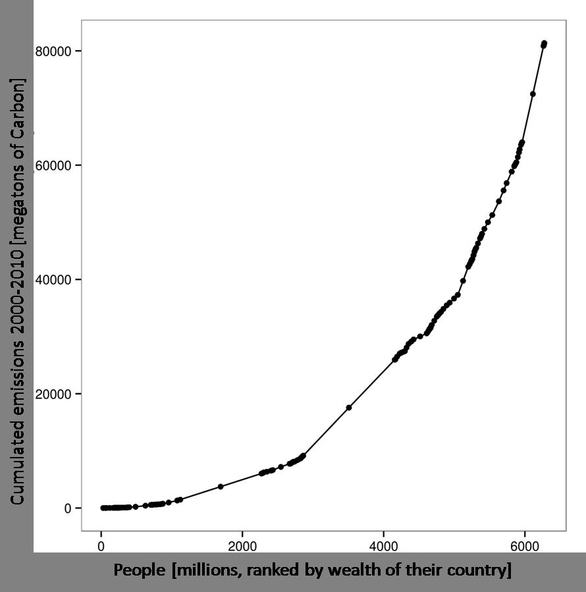

[Figure 1:
Distribution of global carbon emissions over the world population (grouped in countries and ranked by their wealth). The left part of the curve is “flat”, indicating that the bottom billion contributes virtually nothing to global warming. Also, the lower income groups contribute little to global emissions on average. The right part of the curve is “steep”, indicating how much more the lifestyle of the average individual in rich countries contributes to the total global problem.
Data sources: CDIAC for emissions and Penn World Tables 8.0 for GDP and population. Not for all countries was the necessary data available, hence the difference to the actual world population number of more than seven billion people.]
But not only were the poor excluded from participating in human progress, now they are forced to cope with the dreadful byproduct: climate change. This constitutes an unacceptable double-inequality: the poor are responsible for a tiny share of global emissions (Figure 1), yet they have to bear the greatest consequences. Contrary to what some have claimed, it is not the mass of poor people that destroys the planet, but the consumption of the rich. Global warming is the consequence of this development of a few and will affect everyone, but brings devastation especially to the weakest in society. As has been pointed out in the Encyclical, it is not possible to address climate change and poverty consecutively, in either order. It is indispensable to confront them simultaneously, as human development is deeply intertwined with the services the Earth provides. If these services are under threat through manmade environmental destruction, the poor will be the first to suffer. They live in exposed areas and have no resources to adapt to a changing climate. Furthermore, some climate impacts will disproportionately affect many of the developing countries.
Presently, the disparities are engrained so deeply that the poor remain voiceless, well-aware of the changes to their environment, but without any knowledge about the underlying causes. They are continuously kept from forming an opinion on climate change because they lack a formal education, yet their need for a life of dignity has been repeatedly misused as an excuse for inaction on climate change. Hitherto, dignity has remained impossible to attain for the many who live in their own and foreign waste, without access to clean water, exposed to environmental hazards and without the power to shape their own future. The unnecessary hardship the poor have had to experience in a world of abundance can no longer be accepted.
Already, we have not only violated the moral boundaries of our global civil society, but are also leaving the safe operating space of our planet by crossing planetary guardrails [6]. The continuation on this development pathway will not bring prosperity for all, but may end in disaster for most. But it is not an inevitable fate to which humanity has to succumb. As climate change is human-made, it is also in our hands to turn the trend around. Although the Earth system is characterized by great complexities and further research is needed in many areas, the scientific knowledge on climate change impacts is already so profound that it will be impossible to refer to ignorance as a justification for our inaction.
What we have learned
"If the Lord Almighty had consulted me before embarking on the Creation, I would have recommended something simpler" stated Alonso X of Castile in the 13th century. Were this advice taken, we would have been deprived of the exquisite joy that lies in the admiration of the complexity surrounding us – nature itself. Even the most abstract-minded mathematician recognizes the awe-provoking mystery behind the fact that a very simple-looking equation can wonderfully unfold into a beautiful picture of intricacy. The Earth’s climate (in keen competition with the human brain) constitutes perhaps one of the most breathtaking manifestations of this complexity [1, No.20]. We live in an age that grants us the privilege of building on centuries of tradition in natural sciences fueled by human curiosity – this enables us more than ever before to assess the causes of climatic change.
I have had the honor to elaborate on that subject in a contribution to a workshop of the Pontifical Academies of SciencesSustainable Humanity, Sustainable Nature: Our Responsibility last year [7]. It states that “The climate system is a most delicate fabric of interwoven planetary components (such as the atmosphere, the oceans, the cryosphere, the soils, and the ecosystems) that interact through intricate physical, chemical, geological and biological processes (such as advection, upwelling, sedimentation, oxidization, photosynthesis, and evapotranspiration). […] We eventually become aware of the fact that even slightly pulling one single string might have the potential to tear apart the entire fabric.“
This fabric constitutes the parachute for our daily flight in the environment surrounding us, shaken by the mighty forces of nature – and yet a small, privileged group of mankind has been pulling strings ever more strongly since the start of the Industrial Revolution in the 18th century. And as a result, we are already starting to tailspin. For instance, after a “decade of weather extremes” [8] it is now clear that local heat records happen about five times more often than they would in an unchanged climate – that is with an intact parachute [9]. At the same time, although still too far away to be directly visible to most of us (but not to all!), major turbulence is approaching inexorably: almost 20 cm of global mean sea-level rise since 1880, for example, is starting to impact entire societies, washing away the ground they live on or degrading the soil on which they grow their food through salt-water intrusion.
Sea-level rise distinctly illustrates many dilemmas often involved also with other climate change impacts. Rising gauges, for example, are on the one hand caused by the expansion of sea water as it warms, on the other hand by the extra amount of water in our ocean basins stemming from melting glaciers and ice caps. Since most of the Earth’s ice – inherited from many ice ages over countless millennia – is located near the poles on Greenland and the Antarctic continent, its loss by melting reduces the gravitational pull and sets the water free to float more towards the Equator. This is the region on the globe where most of those people are living who do not have the means to purchase reserve parachutes in the form of uphill estates. Another dilemma lies in the long time span between cause and effect – the already damaged fabric will silently but inexorably unravel more and more until the consequences can no longer be ignored. Ice flow changes that are happening now, for instance, in a large ice basin in West Antarctica ([10], [11]) seem to have been triggered by warm ocean waters bathing the floating tongues of the glaciers. But the resulting speed-up of the ice flow – once initiated – can likely not be halted due to nonlinearities in the underlying dynamics. This means that ultimately about 1.2 meters of sea-level rise – in addition to all the anticipated contributions stemming from human interference with the climate system – have to be expected from that single source over the centuries to come.
The West Antarctic ice sheet is – due to the mentioned nonlinearity – a classic example of a tipping element in the Earth System [12]. But there are many more: from the ice sheets and glaciers, to permafrost in the vastness of Siberia and northern North America, to monsoon systems, the Jet Stream and the El Niño-Southern Oscillation pattern, and to biological systems like coral reefs or the Amazon rainforest. What they all have in common is that fundamental changes of state, caused by a relatively small external disturbance, are possible due to the complexity of the associated nonlinear system. Although the respective dynamics of those elements is beginning to be better understood, our ability as human beings to intuitively grasp nonlinearities is surprisingly limited: in our everyday experience, cause and effect are usually closely connected in time, space and extent. This, however, is not the case with the tipping elements: Climate change, caused by this tiny molecule of CO₂, can trigger sudden, irreversible and large-scale disruptions in the above-named interwoven physical and ecological systems. It is therefore of utmost importance for the scientific community to clearly communicate the risks involved with altering our climate – crossing certain thresholds may turn tiny holes in the fabric into long, ever increasing ladders.
The visualization of those risks in Figure 2 aims at making these sometimes dry scientific results come to life: it illustrates a crucial reasoning behind the well-known 2°C guardrail. While for many millennia, human civilization has had the privilege to relish a largely stable Earth temperature (in blue), we are now on track to abandon this climate paradise, as can be seen by the sharp increase in temperature (in black). Depending on the choices we make today, in our future we may follow the green path, respecting the 2°C guardrail, or – if we continue with business as usual – greenhouse gas emissions will lead us along the red path, past 4°C by the end of this century and with even higher warming levels in store after that.
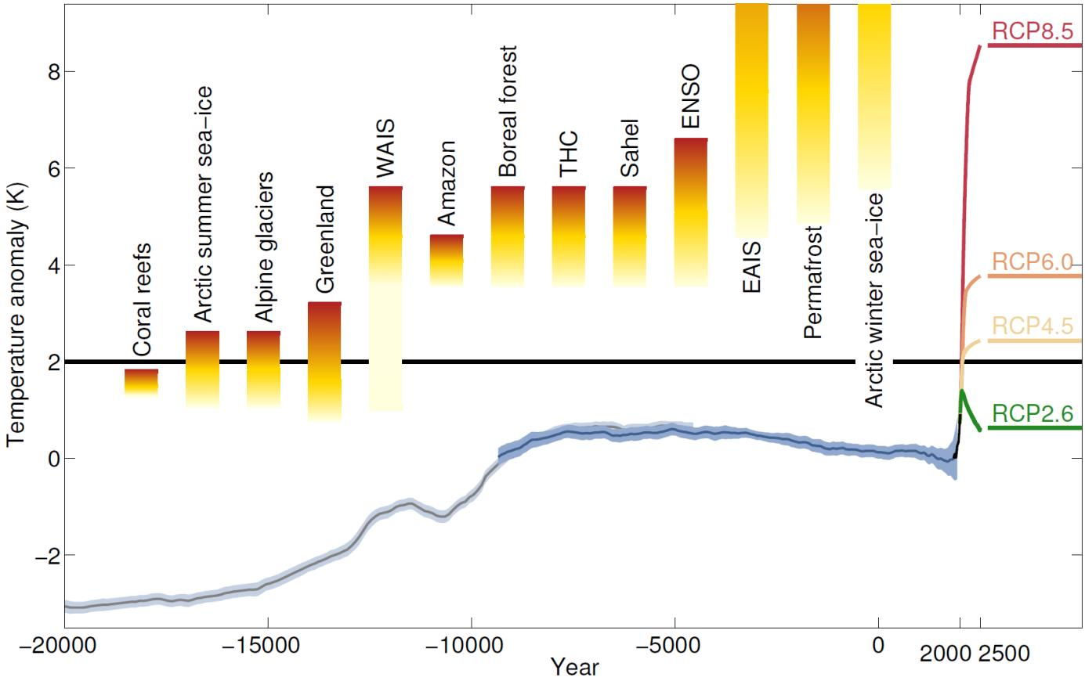
[Figure 2:
Global‐mean surface temperature evolution from the Last Glacial maximum through the Holocene, based on paleoclimatic proxy data ([13], [14]) (light gray), instrumental measurements since 1750 AD (HadCRUT data, black) and different global warming scenarios for the future (see [15] for the latter). Threshold ranges for crossing various tipping points where major subsystems of the climate system are destabilized have been added from refs. ([15]–[20]).]
What difference does it make? This question is often asked with the notion that a doubling of temperature increase would mean a simple doubling in the severity of the consequences. And it reveals the linear thinking that is so natural to most of us. However, this assumption is completely misleading. The complexity of nature gives rise to temperature thresholds which – if crossed – leave the associated tipping element in a fundamentally different state. Those thresholds are visualized in Figure 2 for a number of climatic elements. The coral reefs, for example, are at risk of long-term degradation [16] and the Greenland ice sheet may melt down in the end [20], even if the 2°C guardrail is respected. But the further the temperature rises, the higher is the risk of crossing the tipping point for each element, and the more climatic elements are in danger. The consequences such as the collapse of the “lung of the Earth”, the Amazon rainforest, would be disastrous, not to mention a complete disintegration of the West Antarctic and Greenland ice sheets, associated with about 3.3 and 7 meters of sea-level rise, respectively. As has been addressed also in the Encyclical [1, No. 34], technological advances would not be able to keep up in providing solutions to manage changes of this scale.
The difference between 2 and 4 °C global warming is reflected in these tipping elements. But even without explicitly considering these potential large-scale, non-linear changes, it is indisputable that a 4 °C warmer world has to be avoided ([21]–[23]). For instance, heat extremes, which are virtually absent today and almost certainly never occurred since the rise of human civilization (and not even since the formation of key ecosystems), would become normal in central West Africa following the red path – this is the scenario for business as usual. Such a drastic change would again strike most heavily those who have not eaten from the fruit of fossil fuel burning to any noteworthy extent: the poor.
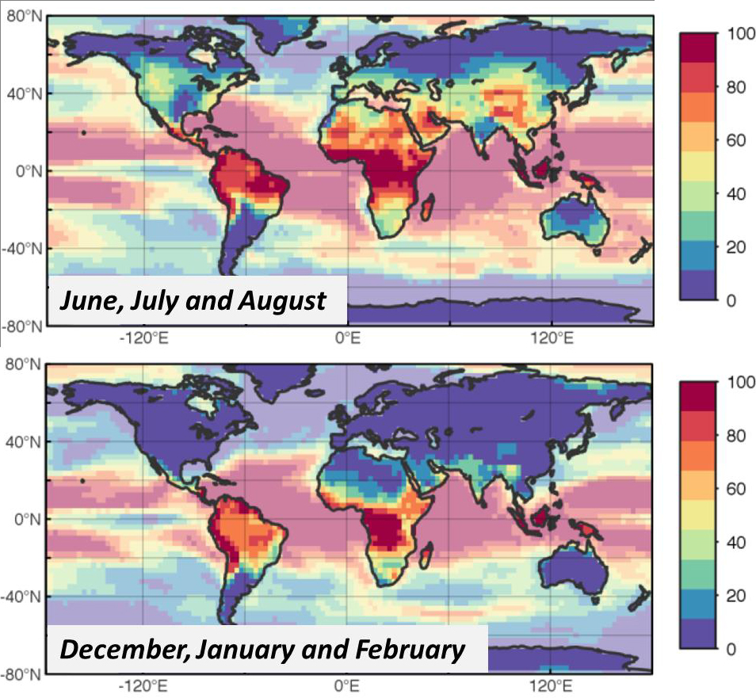
[Figure 3:
Regional distribution of the frequency of extremely hot months (“5σ-months”) in a 4 °C world ( June, July and August between 2080 and 2100). The color coding indicates the percentage of months which are hotter than today by five standard deviations (5σ) – those heat extremes would be virtually absent without climate change. On one end of the color scale is dark blue (0%-10% of all months are hotter by five σ); on the other end dark red (90%-100% of all months are hotter by 5σ). This shows clearly that 5σ-months become the new “climate normal” in the tropical land regions ([24]–[26]).]
What we need to do
The long-term perspective illustrated through the tipping thresholds in Figure 2 reveals a far-reaching insight: Although the poor are the first to suffer and will be most fundamentally affected, all of mankind are ultimately reliant on the same parachute, irrespective of the temporary short-term benefits for a handful. This parachute – a stable climate – being destroyed by the few, is our common good. The Encyclical confirms this assessment which scientists and moral philosophers have claimed in the context of climate policy: “The climate is a global commons of all and for all” [1, No. 20]. The atmosphere is a global good because of its limited disposal space for greenhouse gas emissions. Presently, the upper-middle classes worldwide are rapidly depleting this scarce resource by emitting greenhouse gases in vast amounts. In contrast to the limited disposal space in the atmosphere, fossil fuels, especially coal, are abundant. Hence limiting the increase of global mean temperature to 2°C requires confining the amount of carbon still to be released into the atmosphere to 1000 gigatons of CO₂ (or less). Whereas restricting the use of the atmosphere as a carbon dump is absolutely necessary to avoid intolerable damage and suffering for the many, it will devalue the assets and the property titles of today’s owners of coal, oil and gas. Almost 80 % of coal has to remain underground in a climate-change mitigation scenario compared to a business-as-usual case. Hence, climate policy implies shifting property rights for using the atmosphere from fossil fuel owners to a novel owner – humankind as a whole [27].
It is understandable that there are claims for compensation for the devaluation of the assets in the fossil fuel sector. However, the devaluation of these assets is by no means an illegitimate expropriation because it serves the common good – the avoidance of catastrophic climate risks. The Encyclical draws attention to the principle of “the social obligation of private property”. This goes back to St. Thomas Aquinas and has been further developed by the social teaching of the Catholic Church, in particular by this Encyclical “Laudato si’” of Pope Francis [1, No. 20, 93-95, 156-158]. It maintains that private property, in general, and in natural resource endowments, in particular, is ethically justifiable only if it serves the common good. Moreover, the upcoming devaluation of fossil resources could be viewed as an act of ‘creative destruction,’ instigating a new integral industrial revolution that would bring enormous economic opportunities – possibly also to those who have so far not participated in human progress. The transformation of the way we produce our energy may well cause a greater transformation of society as a whole.
International negotiations over national emission reduction goals, national carbon prices or even a global price, implicitly or explicitly allocate rights for use of carbon space in the atmosphere to nation states, firms and consumers. “Laudato si’” does not provide technical guidance on how to allocate user rights for the atmosphere. However, Pope Francis highlights the ethical dimension of the climate problem and provides fundamental principles to be applied for solutions: the preferential option for the poor, inter- and intragenerational justice, common but differentiated responsibility, orientation to the common good. The Encyclical argues for a global governance structure for the whole spectrum of the planetary commons [1, No. 174]. Putting a price on CO₂ emissions – either in the form of emissions cap & trade systems like the one in Europe or the one that China plans to set up, or through national CO₂ taxes – is an effective instrument to protect the common good.

Figure 4 shows that a mitigation pathway is economically feasible, without significant consumption losses, compared to a business-as-usual scenario. Further, a strong, legally binding target and an adequate CO₂ price would provide businesses with more predictable frameworks to operate in – something that even major oil companies recently called for – and give incentives to invest in clean technologies. This would significantly accelerate innovation in the fields of renewable energy production, distribution and storage and at the same time bring down production costs and retail prices. To spur the build-up of new energy systems in the developing world, to support them in their mitigation efforts as well as in adaptation measures to build climate resilience, financial instruments such as the Green Climate Fund are indispensable. Controlling efficient use of the funding for the benefit of the poor of course is a challenge. Yet insurance systems, for instance, which enable subsistence farmers to economically survive climate-related yield failures and other disasters, illustrate how much can already be done today. Moreover, a variety of solutions have emerged from the scientific discourse, including, for example, international monitoring of national emissions reductions or the establishment of a global ‘climate bank’ to manage the emissions allowance.
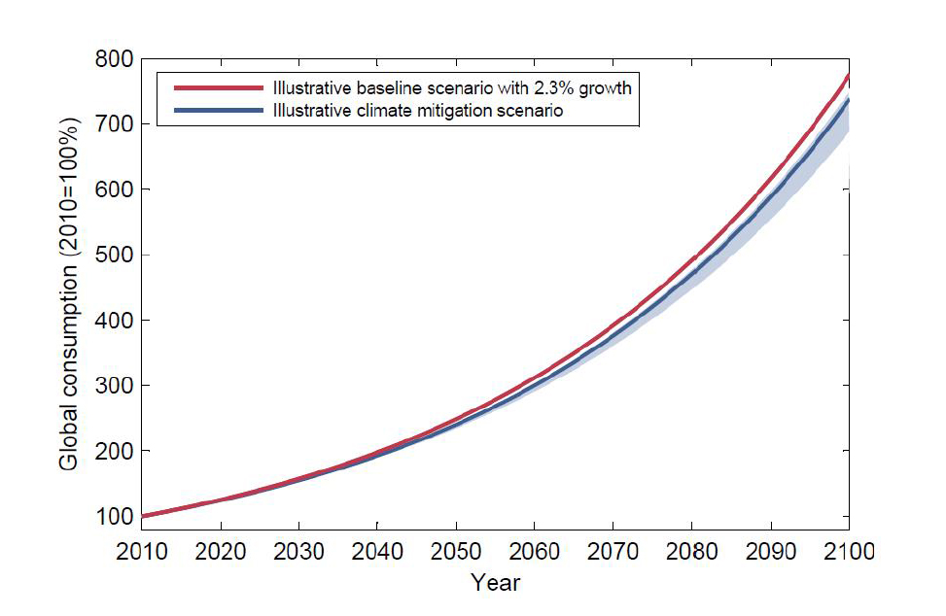
[Figure 4:
“The cost of saving the planet”. The blue mitigation path shows the median reduction of consumption and its uncertainty range as estimated by IPCC, illustrated here relative to a baseline example (red) with 2.3% annual growth. The nearly 8-fold increase in global consumption by the year 2100 in the baseline case is reached 2 years later in the case that includes the median climate mitigation costs. Note that these cost estimates do not consider damages from climate change, which would likely turn out to be a much greater burden than the mitigation costs, nor does it include co-benefits or side effects of mitigation]
Technologically, the deployment of clean energy for all is feasible [28]: this energy, in fact, is available in abundance. All we have to do is develop the means to properly harvest it and responsibly manage our consumption. While we have been working decade after decade on developing an incredibly expensive fusion reactor, we are already blessed with one that works perfectly well and is free to all of us: the Sun. Photovoltaics, wind and energy from biomass are ultimately all powered by sunlight. These new technologies could unfold potential in poor countries where no grid exists to distribute electricity produced by centralized power plants and where settlements may be too distantly located from one another to make such a system feasible. Just like the evolving use of mobile phones without the previous establishment of landlines, developing countries could leapfrog the fossil episode and enter the age of decentralized renewable energy production without detour.
The care for our planet therefore does not have to evolve into a tragedy of the commons. It may well turn into a story of a great transformation in which the opportunity was seized to overcome the profound inequalities. These disparities arose from the geological coincidence of regional fossil fuel distribution controlled by the few and the concomitant exploitation. Today, the implications of our actions and the pathways are clear. It is solely a question of what future we choose to believe in and to pursue [29].
References:
[1] Pope Francis, Carta Encíclica Laudato si’ - Sobre el Cuidado de la Casa Común. Vatican City, 2015.
[2] Pontifical Academy of Sciences and Pontifical Academy of Social Sciences, “Sustainable Humanity Sustainable Nature - Our Responsibility,” Vatican City, 2014.
[3] A Report by the Working Group Commissioned by the Pontifical Academy of Sciences, “Fate of Mountain Glaciers in the Anthropocene,” 2011.
[4] Pontifical Academy of Sciences, “Declaration of Religious Leaders, Political Leaders, Business Leaders, Scientists and Development Practitioners,” Vatican City, 2015.
[5] P. Dasgupta, V. Ramanathan, P. Raven, M. Sánchez Sorondo, M. Archer, P. J. Crutzen, P. Léna, M. J. Molina, M. Rees, J. Sachs, and H. J. Schellnhuber, “Climate Change and the Common Good: A Statement of the Problem and the Demand for Transformative Solutions,” Vatican City, 2015.
[6] W. Steffen, K. Richardson, J. Rockström, S. Cornell, I. Fetzer, E. Bennett, R. Biggs, S. R. Carpenter, C. a. de Wit, C. Folke, G. Mace, L. M. Persson, R. Veerabhadran, B. Reyers, and S. Sörlin, “Planetary Boundaries: Guiding human development on a changing planet,” Science (80-. )., vol. 347, no. 6223, p. 1259855, 2015.
[7] H. J. Schellnhuber and M. A. Martin, “Climate-System Tipping Points and Extreme Weather Events,” in Pontifical Academy of Sciences and Pontifical Academy of Social Sciences: Sustainable Humanity, Sustainable Nature: Our Responsibility, 2014.
[8] D. Coumou and S. Rahmstorf, “A decade of weather extremes,” Nat. Clim. Chang., no. March, Mar. 2012.
[9] D. Coumou, A. Robinson, and S. Rahmstorf, “Global increase in record-breaking monthly-mean temperatures,” Clim. Change, 2013.
[10] E. Rignot, J. Mouginot, M. Morlighem, H. Seroussi, and B. Scheuchl, “Widespread, rapid grounding line retreat of Pine Island, Thwaites, Smith, and Kohler glaciers, West Antarctica, from 1992 to 2011,” Geophys. Res. Lett., vol. 41, pp. 3502–3509, 2014.
[11] I. Joughin, B. E. Smith, and B. Medley, “Marine Ice Sheet Collapse Potentially Underway for the Thwaites Glacier Basin, West Antarctica.,” Science, vol. 735, May 2014.
[12] H. J. Schellnhuber, “Tipping elements in the Earth System.,” Proc. Natl. Acad. Sci., vol. 106, no. 49, pp. 20561–3, Dec. 2009.
[13] S. A. Marcott, J. D. Shakun, P. U. Clark, and A. C. Mix, “A Reconstruction of Regional and Global Temperature for the Past 11,300 Years,” Science, vol. 339, pp. 1198–1201, 2013.
[14] J. D. Shakun, P. U. Clark, F. He, S. A. Marcott, A. C. Mix, Z. Liu, B. Otto-Bliesner, A. Schmittner, and E. Bard, “Global warming preceded by increasing carbon dioxide concentrations during the last deglaciation.,” Nature, vol. 484, no. 7392, pp. 49–54, Apr. 2012.
[15] IPCC, Climate Change 2014: Synthesis Report. 2014.
[16] K. Frieler, M. Meinshausen, A. Golly, M. Mengel, K. Lebek, S. D. Donner, and O. Hoegh-Guldberg, “Limiting global warming to 2 °C is unlikely to save most coral reefs,” Nat. Clim. Chang., vol. 3, pp. 165–170, 2013.
[17] T. M. Lenton, H. Held, E. Kriegler, J. W. Hall, W. Lucht, S. Rahmstorf, and H. J. Schellnhuber, “Tipping elements in the Earth’s climate system.,” Proc. Natl. Acad. Sci., vol. 105, no. 6, pp. 1786–93, Feb. 2008.
[18] A. Levermann, J. L. Bamber, S. Drijfhout, A. Ganopolski, W. Haeberli, N. R. P. Harris, M. Huss, K. Krüger, T. M. Lenton, R. W. Lindsay, D. Notz, P. Wadhams, and S. Weber, “Potential climatic transitions with profound impact on Europe,” Clim. Change, vol. 110, no. 3, pp. 845–878, Jun. 2012.
[19] T. M. Lenton, “Arctic climate tipping points.,” Ambio, vol. 41, no. 1, pp. 10–22, Feb. 2012.
[20] A. Robinson, R. Calov, and A. Ganopolski, “Multistability and critical thresholds of the Greenland ice sheet,” Nat. Clim. Chang., vol. 2, no. 4, pp. 1–4, Mar. 2012.
[21] World Bank, “Turn Down The Heat: Why a 4°C Warmer World Must be Avoided,” 2012.
[22] World Bank, “Turn Down the Heat: Climate Extremes, Regional Impacts, and the Case for Resilience,” 2013.
[23] World Bank, “Turn Down the Heat : Confronting the New Climate Normal,” 2014.
[24] World Bank, “Turn Down the Heat: Climate Extremes, Regional Impacts, and the Case for Resilience,” 2013.
[25] World Bank, “Turn Down the Heat : Confronting the New Climate Normal,” 2014.
[26] World Bank, “Turn Down the Heat: Why a 4°C Warmer World Must be Avoided,” 2012.
[27] O. Edenhofer, C. Flachsland, M. Jakob, and K. Lessmann, “The Atmosphere as a Global Commons: Challenges for International Cooperation and Governance,” in The Oxford Handbook of the Macroeconomics of Global Warming, L. Bernard and W. Semmler, Eds. Oxford: Oxford University Press, 2015.
[28] IPCC, Climate Change 2014: Mitigation of Climate Change. Contribution of Working Group III to the Fifth Assessment Report of the Intergovernmental Panel on Climate Change - Chapters 6 and 7. Cambridge, United Kingdom and New York, NY, USA: Cambridge University Press, 2014.
[29] O. Edenhofer, J. Wallacher, H. Lotze-Campen, K. Reder, M., and J. B., Müller, Climate Change, Justice and Sustainability - Linking Climate and Development. Springer, 2012.

